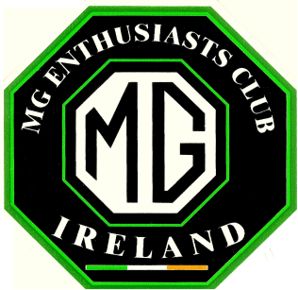
MGEC ANNUAL TOUR 2026
Co. Cork
Sunday 6 September to Wednesday 9 September

Dear Member:

This year’s Annual Tour will take us to West Cork, based at the Eccles Hotel, Glengarriff, overlooking Bantry Bay. With a 250-year history, the Hotel retains its old world charm while offering modern facilities, including a Spa, and there is a spacious car park out front.

To ensure your place on the Tour, please return this form with the Tour entry fee of €25.00 per person, which includes a Pre-dinner Drink on Sunday evening, Souvenir Rally Plate and your Rally Book. On receipt of your entry, we will send you a reservation number and contact details to enable you to book the Hotel at the special tour rate.

You must book the Hotel yourself by 1 June 2026 latest. After that date any MGEC reserved rooms that hasn’t been booked will be made available to the general public at the normal rate. A limited number of rooms have been reserved, so book as early as possible to avoid disappointment.

Booking confirmed by Credit Card (no deposit required), bill payable on departure.

The rate is €125 per person sharing per night on a Dinner, Bed and Breakfast Basis.
(There is a €25.00 Single Supplement per night).

Please return the form with Tour entry fee, to arrive no later than Friday 24 April 2026. .

Please complete the form below and return it with the appropriate fee.
Transfers to MGEC account at IE60BOFI901095 32757550 (Include “Name” and “Tour”)

Name(s)___________________________ Staying 2___ 3___ nights (tick)

Address ______________________________________________________

Mobile no_______________________Email__________________________

Tour entry fee €25.00 per person, total €_______ payable by 24 April 2026
Send to: Alan Haugh, Hunters Grove, Old Long Hill, Kilmacanogue, Co. Wicklow, A98 PY52
Tel: 087 6896055 Email: alanjhaugh@gmail.com

